08.08.18
BMA Avalere Twitter Chat
From: Natalia Gonzalez – Communications Team
To: Better Medicare Alliance
____________________________________________________________________________
Overview:
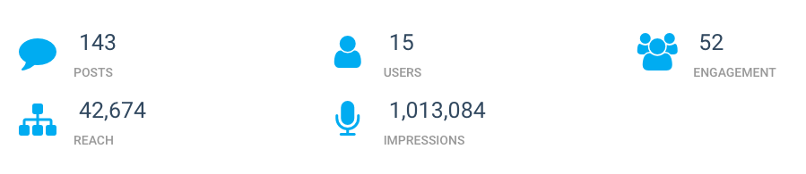
The Twitter Chat lasted from 1:00 pm to 2:00 pm
Participants: 8
Questions submitted: 11
5 Submitted through email
6 Real time questions

Twitter chat transcript:
BMA‏ @BMAlliance
15 minutes left! Get ready to discuss why #MedicareAdvantage is keeping our seniors healthy. Read new report here: http://ow.ly/uLGM30lk7vu #ValueofMA
BMA‏ @BMAlliance
Let’s get started! #ValueofMA
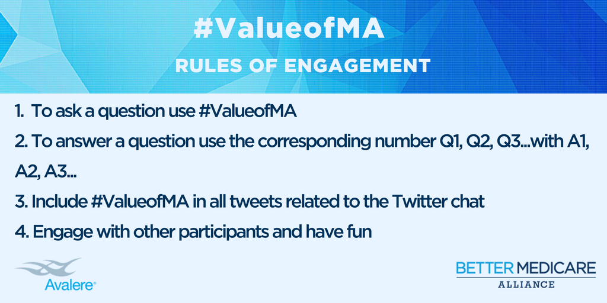
BMA‏ @BMAlliance
Welcome to BMA and Avalere’s Twitter chat! Today we will discuss how a new report shows that Medicare Advantage achieves better health outcomes for ppl with chronic conditions than Traditional Medicare. Please use the #ValueofMA hashtag to join the conversation!
BMA @BMAlliance
Joining us today we have as hosts @JamesMichel, BMA Director of Policy and Christie Teigland, who will be tweeting from @AvalereHealth handle #ValueofMA
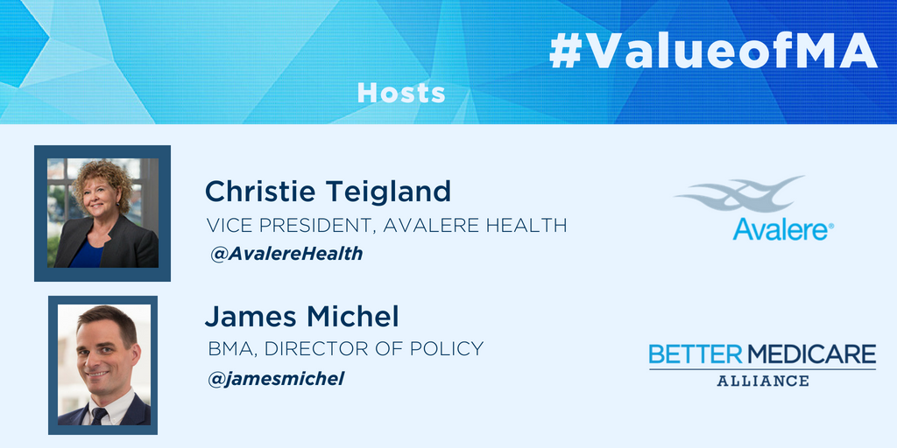
BMA‏ @BMAlliance
Participants introduce yourself and your professional background #ValueofMA
James Michel‏ @jamesmichel
James here, Policy Director at @BMAlliance. We are always interested in funding research that examines #MedicareAdvantage and answers burning questions! #ValueofMA
Avalere Health‏ @avalerehealth
I'm a VP of Advanced Analytics at Avalere Health & was principal investigator of this study. #ValueofMA
BMA @BMAlliance
Welcome to the Better Medicare Alliance and @AvalereHealth Twitter Chat on #MedicareAdvantage https://t.co/r1hA0nVmMg
BMA‏ @BMAlliance
Hi glad you joined us today! We encourage you to start tweeting questions for Christie and James using the #ValueofMA
BMA @BMAlliance
Remember to send a question to our hosts by using the hashtag #ValueofMA
BMA‏ @BMAlliance
First we will begin with questions already submitted to us! #ValueofMA
BMA‏ @BMAlliance
Q1 What are the key elements in Medicare Advantage that led to better cost and quality outcomes than FFS Medicare? #ValueofMA
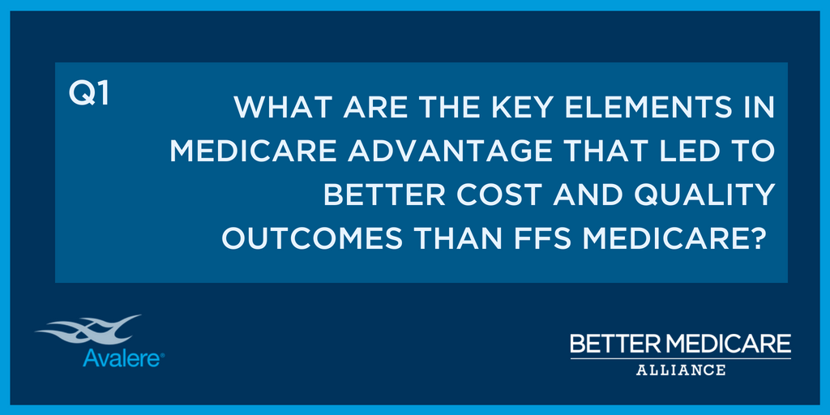
Avalere Health‏ @avalerehealth
A1: While the study did not explore causal relationships, the higher frequency of primary care visits, preventive services, and integrated care management in #MedicareAdvantage could be the primary reason MA beneficiaries experienced better health outcomes. #ValueofMA
BMA‏ @BMAlliance
Q2 How do you think this research corroborates or refutes existing research on Medicare Advantage? #ValueofMA
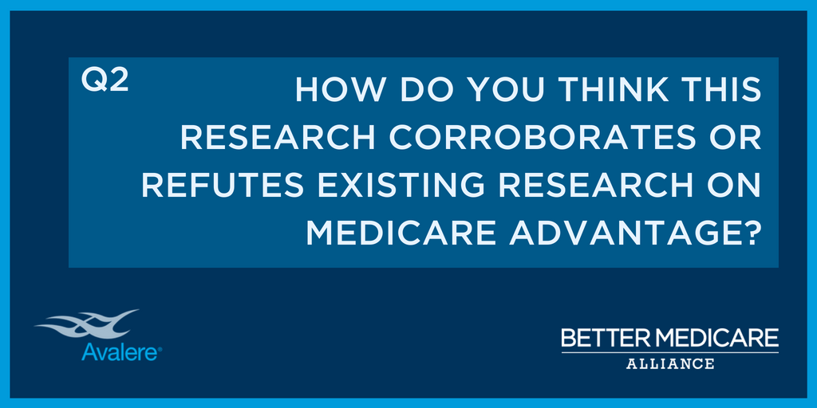
James Michel‏ @jamesmichel
A1. The capitated financial model of MA has built-in incentives to better manage care and promote preventive care, avoid hospital, etc. #ValueofMA
BMA @BMAlliance
Q3 Question from Dr. Anand Parekh @AParekhBPC: What are some of the preventive services/tests that are of greater use in MA compared to FFS Medicare that you believe result in better care management leading to improved health outcomes and lower health care costs? #ValueofMA
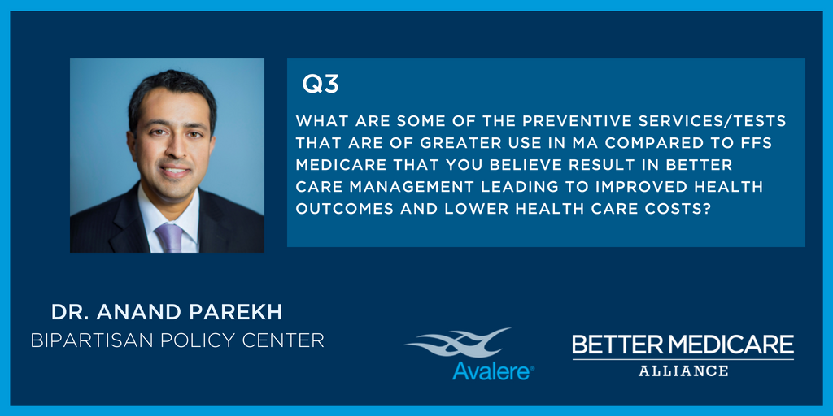
James Michel‏ @jamesmichel
A2. The findings corroborate previous research showing MA uses less high-cost services where low-cost services can substitute. MA C-SNPs for diabetics have also been shown to boost PCP visits, which our research also showed. #ValueofMA
Avalere Health‏ @avalerehealth
A2: #MedicareAdvantage benes have the same chronic conditions as FFS #ValueofMA
Ellen Milhiser‏ @CongSynopsis
#valueofma Do you attribute any of the improved care/outcomes to the use of capitated payments under MA, with plans having greater financial interest in managing care rather than just providing it? Could ACOs have a similar impact?
James Michel‏ @jamesmichel
Hi Ellen! We suspect that the built-in financial incentives are driving what we see, but we did not specifically look at -causes- in this study. We would also love to do a follow-on analysis looking more closely at #ACO orgs! We know @avalerehealth can do that. #ValueofMA
Consumer Action‏ @consumeraction
Have questions about Medicare Advantage v. traditional Medicare? Follow the discussion happening now and submit your questions for the experts! Use the hashtag #ValueofMA
BMA‏ @BMAlliance
Q4 Question from Chris Adamec @theadamec @PCPCC: The report shows that Dual eligible beneficiaries in MA saw their primary care providers more frequently than dual eligible beneficiaries in FFS Medicare Does this increased access to primary care show up in the broader MA program? What further research has been done/needs to be done in this area? #ValueofMA
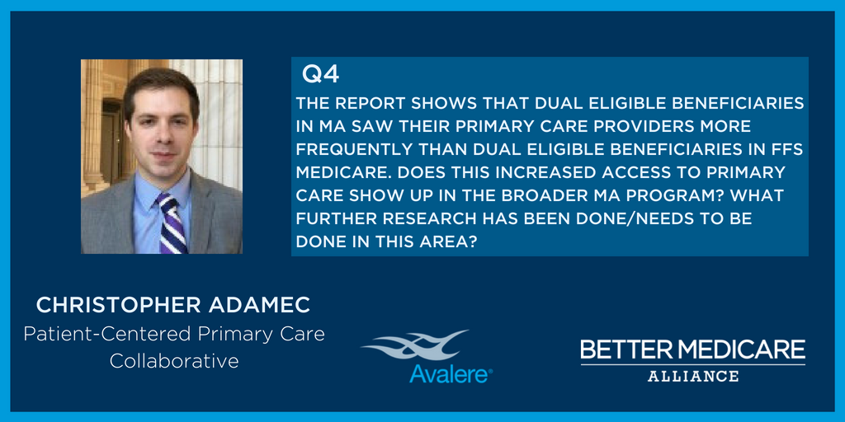
Avalere Health‏ @avalerehealth
A3: Two shown in the study were breast cancer screening and LDL testing. Generally, the consistently higher spending on professional services & tests in #MedicareAdvantage seems to be associated w/ better care mgmt & outcomes, primarily fewer ER & hospital stays. #ValueofMA
Tiffany Alessandra‏ @Tiffany_A_Brown
#valueofma what about demographics and the notion that private plans tend to enroll healthier people?
Avalere Health‏ @avalerehealth
#MedicareAdvantage & FFS benes had similar demographic profiles, including age, gender, & prevalence of chronic conditions & similar levels of severity based on burden of illness. They look very similar in FFS. #ValueofMA
James Michel‏ @jamesmichel
This is a myth that will not die! We hope this research finally puts this misconception to bed…permanently! #ValueofMA
James Michel‏ @jamesmichel
Hi Tiffany - great Q! I believe that question is coming up shortly. #ValueofMA
BMA @BMAlliance
Q5 What was the most surprising research finding? #ValueofMA
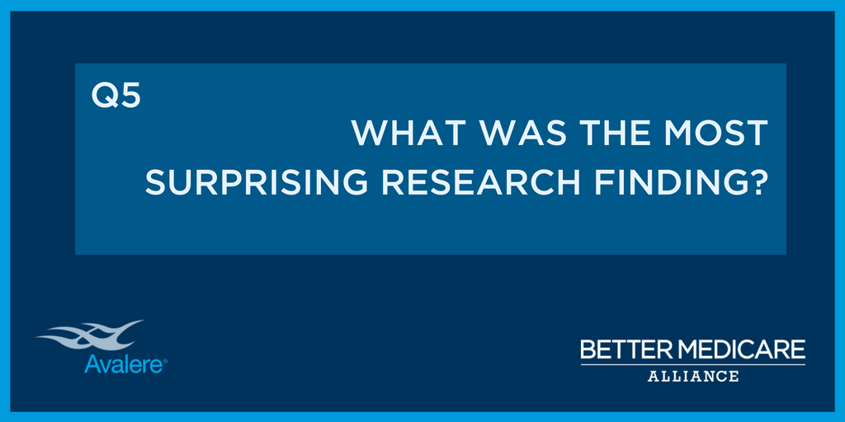
Avalere Health‏ @avalerehealth
A4, THREAD 1/2: While our analysis examined a nationally representative sample of both MA & FFS benes, we were looking only at benes w/ 1 of 3 chronic conditions. #ValueofMA
Avalere Health‏ @avalerehealth
A4, THREAD 2/2: These chronic conditions were very highly prevalent in both populations, so we suspect that results would translate to the broader population, but we would need to do that analysis to know for sure. #ValueofMA
Consumer Action‏ @consumeraction
Read this report and then submit your questions with the hashtag #ValueofMA--going on now!
James Michel‏ @jamesmichel
A5. Well, there were a few, but certainly the finding that MA patients had more risk factors, such as mental health and substance abuse, than FFS. That alone predicts worse outcomes in #MedicareAdvantage, but in fact we see better outcomes in MA! #valueofMA
BMA‏ @BMAlliance
Q6 -Question from @AParekhBPC: Has a similar study been done (or is one being contemplated) comparing MA and FFS Medicare ACOs? #ValueofMA
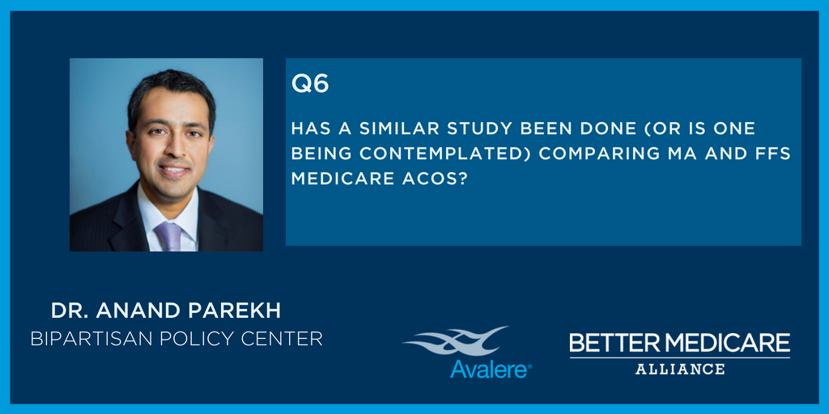
Avalere Health‏ @avalerehealth
A5: The significantly lower rates of hospitalizations and ER visits was striking #ValueofMA
Ellen Milhiser‏ @CongSynopsis
#valueofma I see that there were .4 million more MA beneficiaries studied than FFS. Could this have skewed the findings in any way?
James Michel‏ @jamesmichel
No, we don’t believe so, because both the study population distributions were nationally representative and sufficient in size to show average differences. #ValueofMA
Avalere Health‏ @avalerehealth
A6: We have capability to do such an analysis. The providers are identified in the data and we can link individual providers to proprietary databases that identify affiliation with ACOs, integrated delivery networks and health systems. #ValueofMA
BMA @BMAlliance
Q7 What additional analysis could be done to build on the findings of this report? #ValueofMA
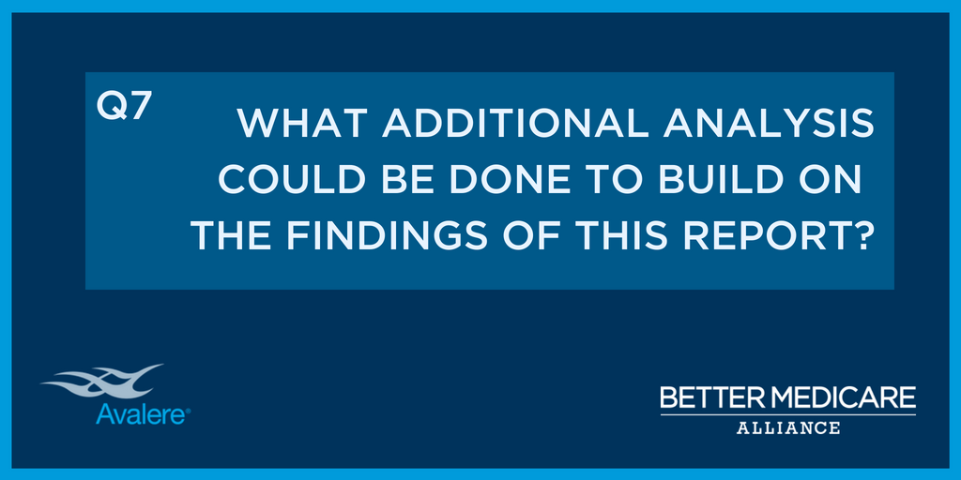
Avalere Health‏ @avalerehealth
A7, THREAD 1/3: We did not look at Part D costs as part of this analysis due to access to that data in FFS, but that would be a logical next step to examine, as drug costs are such an important piece of the health care debate today. #ValueofMA
Avalere Health‏ @avalerehealth
A7, THREAD 2/3: This study was also descriptive in nature. It didn't look at causality or the reasons behind the results. So as more data become available, it would be helpful to see if we could assess root causes behind why #MedicareAdvantage outperforms FFS. #ValueofMA
Avalere Health‏ @avalerehealth
A7, THREAD 3/3: We also didn't adjust results for clinical & social risk factors which could influence results. #ValueofMA
Tiffany Alessandra‏ @Tiffany_A_Brown
#ValueofMA did the research account for any differences in coding intensity?
James Michel‏ @jamesmichel
Great Q! Because @avalerehealth used similarly sourced encounter data, captured by the provider for both populations, it does not include any extra diagnosis coding that is used for payment purposes, so it doesn’t affect the results #ValueofMA
James Michel‏ @jamesmichel
A7. We looked at 3 specific chronic conditions in this study - we could look at others, or at the populations more broadly. We also did not look at drugs here, which we would love to do as a next phase of research with @avalerehealth #ValueofMA
BMA‏ @BMAlliance
Remember to send a question to our hosts by using the hashtag #ValueofMA
BMA‏ @BMAlliance
Q8 from @AParekhBPC : Is it your impression that greater complexity of the beneficiary (e.g., higher chronic conditions, functional limits, SUD/mental illness, dual) the more likely that one will see better health outcomes, and specifically, lower health costs in MA? #ValueofMA
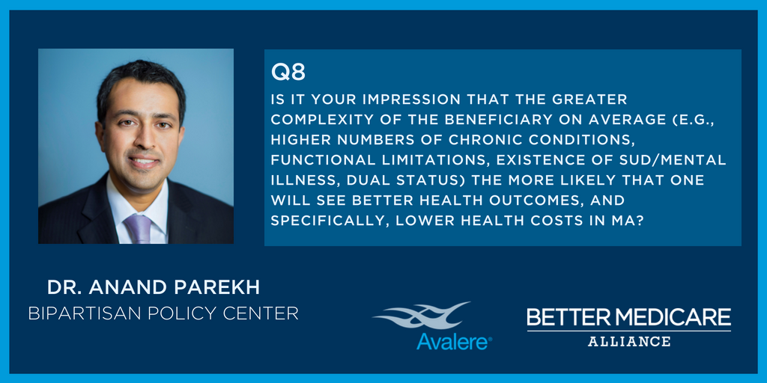
Avalere Health‏ @avalerehealth
A8, THREAD 1/3 #MedicareAdvantage didn’t have higher number of chronic conditions & we did not specifically look at functional limitations in this study, but MA did have a higher proportion of clinical risk factors. #ValueofMA
Avalere Health‏ @avalerehealth
A8, 2/3: These risk factors include more dual / low income subsidy, more disabled, more racial/ethnic minorities, more alcohol/drug substance abuse & more severe mental illness. #ValueofMA
Avalere Health‏ @avalerehealth
A8, 3/3: The presence of these risk factors makes it more likely #MedicareAdvantage benes would have worse health outcomes & higher costs. Thus, the better outcomes & lower costs are likely underestimated. #ValueofMA
BMA‏ @BMAlliance
Q9: Question from Neal Kaufman of Canary Health @NealKaufman @CanaryHealth: How has patient self-management support been incorporated into MA plans? #ValueofMA
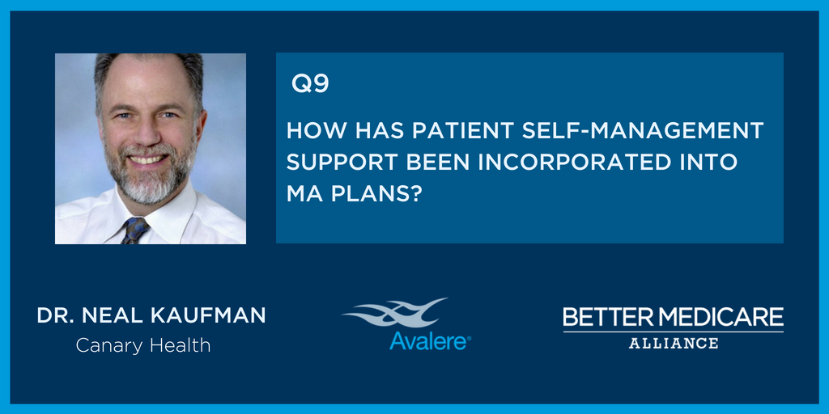
BMA‏ @BMAlliance
A9: We know Medicare Advantage plans are implementing care coordination and wellness programs. Though this was not studied in this report, we hope to examine this further in the future, particularly as new flexibilities are introduced.- @BMAlliance
UM V-BID Center‏ @UM_VBID
A1) V-BID in MA has improved cost and quality outcomes by encouraging use of high-value services and discouraging low-value ones. #ValueofMA Learn more:https://t.co/eF7EDp3gvv
BMA‏ @BMAlliance
Hey, great to have you join! Looking forward to your questions! #ValueofMA
UM V-BID Center‏ @UM_VBID
#ValueofMA Additional analysis should consider lowering health care expenditures to ensure access to high quality clinical care. Read more about V-BID in MA: http://bit.ly/MA1page
BMA‏ @BMAlliance
Q10: What should policymakers take away from the key findings in this report? #ValueofMA
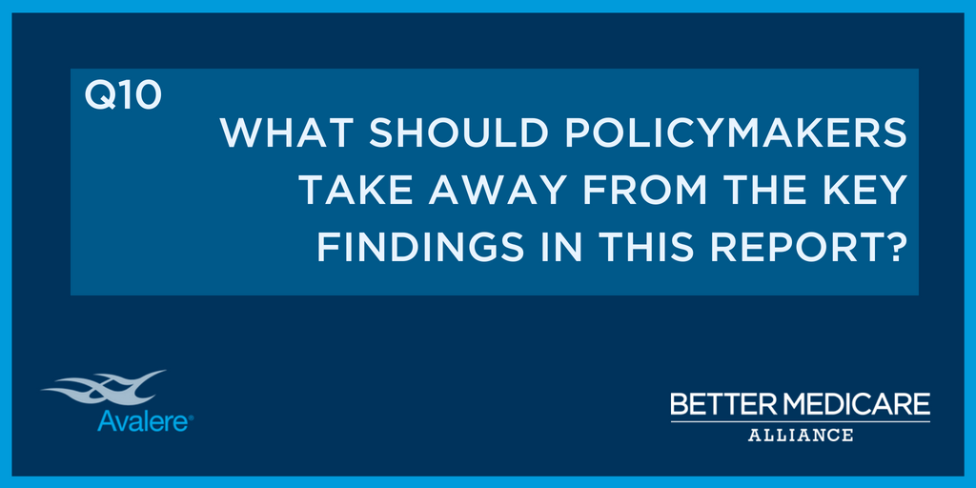
BMA @BMAlliance
Ten Minutes left! Send us your question about how #MedicareAdvantage outperforms Traditional Medicare for people with chronic conditions. Join in today’s Twitter chat by using #ValueofMA
James Michel‏ @jamesmichel
A10. The kinds of innovations in care delivery that policymakers are looking to expand are already happening in #MedicareAdvantage. MA should continue to be supported and strengthened, and learnings should be applied across other payers! #ValueofMA
UM V-BID Center‏ @UM_VBID
@BMAlliance In 2018, the MA model was expanded to include dementia and rheumatoid arthritis. Moving forward, what do you think are the next steps to continue expanding coverage for high-value services? #ValueofMA
James Michel‏ @jamesmichel
For one, VBID models should continue to be expanded! It’s an excellent way to engage patients in their own care and weed out low-value services. We wouldn’t mind seeing VBID allowed in Part D the way it was recently allowed in #MedicareAdvantage… #ValueofMA
Avalere Health‏ @avalerehealth
A10: Policymakers should want to learn more about specific ways #MedicareAdvantage is providing care that improves outcomes & lowers cost in high need benes #ValueofMA
BMA @BMAlliance
What a great conversation! We are wrapping up, thank you for participating! #ValueofMA
BMA‏ @BMAlliance
Special thanks to our hosts @JamesMichel & @AvalereHealth! #ValueofMA

